9º B2
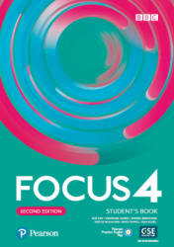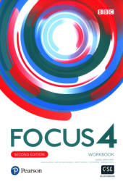

Focus 4 Second Edition Students Ed. Pearson
Focus 4 Second Edition Workbook Ed. Pearson

ALBERTI, ANACLARA
ALONZO MARINA
ALTEZ, JOSEFINA
ARIM, NADIA
BATTHYANY, KLOE
BELLO, MATIAS
BENSASSON, SOFIA
CAJAL, RODRIGO
CAMAROTTA, ANDRÉS
CAMIROTTE, FACUNDO
CAPDEVILLE JULIETA
CARVALLIDO ANTONIO
CASTALDI, VITTORIA
CAYOTA, JUANA
COSTA, JULIAN
DE LOS SANTOS, LUCAS
DIAZ, FRANCISCA
ESTOYANOFF FLORENCIA
FERREIRA SANTIAGO
FERRO FELIPE *
GADEA FACUNDO
GUTIERREZ, FLORENCIA
ILLARRAMENDI LUCAS
LUNA SANTIAGO
LÓPEZ SANTIAGO
LUTZEN JUAN MANUEL
MAGURNO, MITCHELL
MEDICI, VICTORIA*
MEDINA, SANTIAGO
MORA FACUNDO*
OUTERELO CAMILA
PADILLA, CANDELARIA
PUÑALES, LOLA
QUIROGA, BORJA
RODRIGUEZ SANTIAGO
RODRIGUEZ, AGUSTINA
RUÍZ VALENTINA
SESSER JOSEFINA*
TRUSSICH MANUELA
USERA, MATEO
VARGAS JIMENA
VAZQUEZ, EMMA
ZANOLLI AGUSTÍN

